Sukkur IBA University


Data Structure Algorithm

Name: Tariq Mehmood
CMS ID: 023-23-0127
Semester: 3rd
Section: E
Submitted by: Sir Riaz Hussain
Lab No: 04

Q1:
class Node{
Node next;
Node prev;
int data;
public Node (int data){
this.data=data;
this.next=null;
this.prev=null;
}
}
public class Task1{
Node head;
Node tail;
int size=0;
void addToFront(int data){
size++;
Node newNode=new Node(data);
if(head==null){
head=newNode;
tail=newNode;
}
else{
newNode.next=head;
head.prev=newNode;
head=newNode;

}
}
int getFrontItem(){

if(head==null){
System.out.println("Linked list is empty");
}
return head.data;

}
void removeFrontItem(){
size--;
if(head==null){
System.out.println("Linked list is empty");
return;
}
head=head.next;
}
void addToBack(int data){
size++;
Node newNode=new Node(data);
if(head==null){
head=newNode;
tail=newNode;
return;
}
tail.next=newNode;
newNode.prev=tail;
tail=newNode;
}
int getBackItem(){

if(head==null){
System.out.println("Linked list is empty");
}
return tail.data;

}
void removeBackItem(){
size--;
if(head==null){
System.out.println("Linked list is empty");
return;
}
tail=tail.prev;
tail.next=null;
}
void find(int key){
Node temp=head;
if(head==null){
System.out.println("Linked list is empty");
return;
}
while (temp!=null) {
if(temp.data==key){
System.out.println(key+" is Presenet in list");
return;
}
temp=temp.next;
}
System.out.println(key+" is not Presenet in list");
}
void Remove(int key){
size--;
Node currnt=head;
while(currnt!=null){
if(currnt.data==key){
if(currnt.prev!=null){
currnt.prev.next=currnt.next;
}
else{
head=currnt.next;
}
if(currnt.next!=null){
currnt.next.prev=currnt.prev;
}
else{
tail=currnt.prev;
}
return;
}
currnt=currnt.next;
}
}
void addKeyBeforeNode(int key, int data){
//size++;
Node newNode=new Node(data);
if(head==null){
System.out.println("Linked list is empty");
return;
}
Node temp=head;
while (temp.next!=null) {

temp=temp.next;
}
}
void isListEmpty(){
if(head==null){
System.out.println("List is empty ");
return;
}
System.out.println("The list has size is = "+size);

}
void addKeyAfterNode(int key, int data){
//size++;
Node newNode=new Node(data);
if(head==null){
System.out.println("Linked list is empty");
return;
}
Node temp=head;
while (temp.next!=null) {

temp=temp.next;
}
}
void display(){
Node temp=head;
if(head==null){
System.out.println("Linked list is empty");
}
while (temp!=null) {
System.out.print(temp.data+" > ");
temp=temp.next;
}
System.out.println("null");
}
public void Connect(){
Node temp=head;
while (temp!=null) {
if(temp.next!=null){
temp.next.prev=temp;
}
temp=temp.next;
}
}
public static void main(String[] args) {
Task1 DL=new Task1();
DL.addToFront(5);
DL.addToFront(6);
DL.addToFront(7);
DL.display();
DL.addToBack(44);
System.out.println(DL.getFrontItem());
System.out.println("The first Item has Removed ");
DL.removeFrontItem();

DL.display();
System.out.println(DL.getBackItem());
DL.removeBackItem();
DL.display();
DL.find(15);
DL.Remove(5);
//DL.addKeyBeforeNode(5,35);
DL.display();
DL.isListEmpty();

}
}

Output
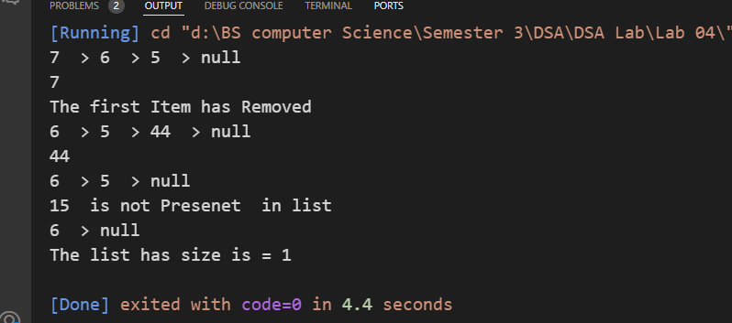
Q2:
class Node{
Node next;
Node prev;
int data;
public Node (int data){
this.data=data;
this.next=null;
this.prev=null;
}
}
public class Task2{
Node head;
Node tail;
int size=0;
void addToBack(int data){
size++;
Node newNode=new Node(data);
if(head==null){
head=newNode;
tail=newNode;
return;
}
tail.next=newNode;
newNode.prev=tail;
tail=newNode;
}
void removeBackItem(){
size--;
if(head==null){
System.out.println("Linked list is empty");
return;
}
tail=tail.prev;
tail.next=null;
}
void PrintLnReverseOrder(){
if(tail==null){
System.out.println("Linked list is empty");
return;
}
Node temp=tail;
while (temp!=null) {
System.out.print(temp.data+" ");
temp=temp.prev;

} System.out.println("null");
}
void display(){
Node temp=head;
if(head==null){
System.out.println("Linked list is empty");
}
while (temp!=null) {
System.out.print(temp.data+" > ");
temp=temp.next;
}
System.out.println("null");
}
public static void main(String[] args) {
Task2 DL=new Task2();
DL.addToBack(5);
DL.addToBack(6);
DL.addToBack(7);
DL.display();
DL.PrintLnReverseOrder();

}
}

Output
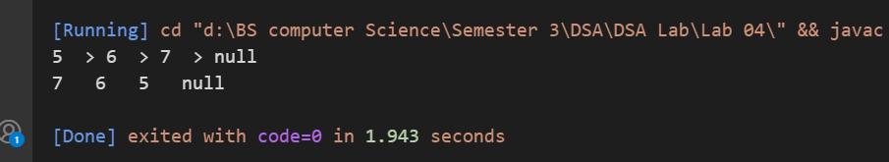

Q3
class Node {
int data;
Node next;
Node (int data){
this.data=data;
this.next=null;
}
}
public class Task3{
Node head;
int size=0;
void addToFront(int data){
Node newNode=new Node(data);
if(head==null){
head=newNode;
newNode.next=head;//Circular link
return;
}
Node temp=head;
while (temp.next!=head) {
temp=temp.next;
}
temp.next=newNode;
newNode.next=head;//newNode.next=head;//Circular Link
head=newNode;
}
void addToBack(int data){
Node newNode=new Node(data);
if(head==null){
head=newNode;
newNode.next=head;//Circular link
return;
}
Node temp=head;
while (temp.next!=head) {
temp=temp.next;
}
temp.next=newNode;
newNode.next=head;
}
void removeFront(){
if(head==null){
System.out.println("Linked list is empty");
return;
}
head=head.next;
}
void removeBack() {
if (head == null) {
System.out.println("Linked list is empty");
return;
}
if (head.next == head) { // Only one node
head = null;
return;
}
Node temp = head;
while (temp.next.next != head) {
temp = temp.next;
}
temp.next = head; // Second last node points to head
}
void display(){
if(head==null){
System.out.println("Linked list is empty");
return;
}
Node temp=head;
do {
System.out.print(temp.data + " > ");
temp = temp.next;
} while (temp != head);
System.out.println();
}
public static void main(String[] args) {
Task3 CL=new Task3();
CL.addToBack(45);
CL.addToBack(6);
CL.addToFront(76);
CL.addToFront(46);
CL.addToFront(56);
CL.display();
CL.removeFront();
CL.removeBack();
CL.display();
}
}
Ouput
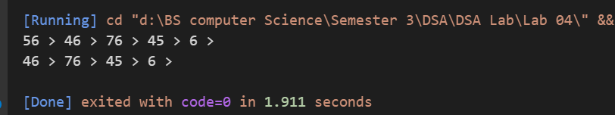
Q4:
class Node {
int data;
Node next;
Node (int data){
this.data=data;
this.next=null;
}
}
public class Task4{
Node head;
int size=0;
void addToFront(int data){
Node newNode=new Node(data);
if(head==null){
head=newNode;
newNode.next=head;//Circular link
return;
}
Node temp=head;
while (temp.next!=head) {
temp=temp.next;
}
temp.next=newNode;
newNode.next=head;//newNode.next=head;//Circular Link
head=newNode;
}
void addToBack(int data){
Node newNode=new Node(data);
if(head==null){
head=newNode;
newNode.next=head;//Circular link
return;
}
Node temp=head;
while (temp.next!=head) {
temp=temp.next;
}
temp.next=newNode;
newNode.next=head;
}
void removeFront(){
if(head==null){
System.out.println("Linked list is empty");
return;
}
head=head.next;
}
boolean hasCycle(){
if(head==null|| head.next==null){
return false;
}
Node fast=head;
Node slow=head;
while (fast!=null && fast.next!=null ) {
slow=slow.next;
fast=fast.next.next;

// If they meet, there's a cycle
if (slow == fast) {
return true;
}
}
return false;
}
void display(){
if(head==null){
System.out.println("Linked list is empty");
return;
}
Node temp=head;
do {
System.out.print(temp.data + " > ");
temp = temp.next;
} while (temp != head);
System.out.println();
}
public static void main(String[] args) {
Task4 CL=new Task4();
CL.addToBack(45);
CL.addToBack(6);
CL.addToFront(76);
CL.addToFront(46);
CL.addToFront(56);
CL.display();
System.out.println("Does the list have a cycle? " + CL.hasCycle());
//CL.removeFront();

//CL.display();
Task4 CL2=new Task4();
Node a=new Node(1);
Node b=new Node(2);
Node c=new Node(3);
Node d=new Node(4);
a.next=b;
b.next=c;
c.next=d;
d.next=null;
CL2.head=a;
System.out.println("Does the list have a cycle? " + CL2.hasCycle());

}
}
Output
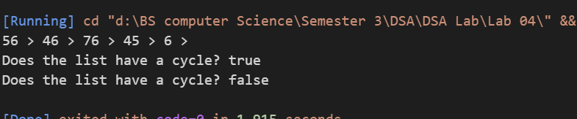
Q5:
class Node {
int data;
Node next;
Node (int data){
this.data=data;
this.next=null;
}
}
public class Task5{
Node head;
int size=0;
void addFront(int data){
size++;
Node newNode=new Node(data);
if(head==null){
head=newNode;
return;
}
newNode.next=head;
head=newNode;
}
void addToBack(int data){
Node newNode=new Node(data);
size++;
Node temp=head;
if(head==null){
head=newNode;
return;
}
else{
while (temp.next!=null) {
temp=temp.next;
}
temp.next=newNode;
}
}
int FindMiddleNode(){
if(head==null){
System.out.println("Linked list is empty");
}
Node fast=head;
Node slow=head;
while (fast!=null &&fast.next!=null ) {
slow=slow.next;
fast=fast.next.next;
}
System.out.println("The Middle Nodes Found "+slow.data);
return slow.data;
}
void display(){
Node temp=head;
if(head==null){
System.out.println("Linked list is empty");

}
while (temp!=null) {
System.out.print(temp.data+" > ");
temp=temp.next;
}
System.out.println("Null ");
}

public static void main(String[] args) {
Task5 LinkedList=new Task5();
LinkedList.addFront(4);
LinkedList.addFront(5);
LinkedList.addFront(6);
LinkedList.addFront(7);
LinkedList.addFront(8);
LinkedList.addFront(9);
LinkedList.display();
System.out.println("Return Midddle Node :"+LinkedList.FindMiddleNode());
}
}
Output
